**MSDS-6372 Applied Statistics - Team Project #1 Report**

**GOAL1 - Prediction of Individual Property Values**

* Introduction

We were tasked with modeling and making projections of real estate prices using data provided by Sberbank of Russia. The data provided were in two files, modelingData.csv and projectionData.csv.

Using the data we were asked to answer two questions. The first item to address was the development of a model that minimized the Root Mean Squared Logarithmic Error (RMSLE). The second item to address was to make projections of the mean price of properties from July 2015 to July 2016. For second topic, please refer to the section [GOAL2]

* Data Description
  1. The modelingData.csv file contains properties sold between August 20, 2011 and June 30, 2015
     + 25471 observations / rows
     + 292 variables / columns
  2. The prediction target file, predictionData.CSV contains predictions on properties sold between July 2015 and May 2016
     + 5000 observations / rows
     + 291 variables / columns
  3. For further details on data description, please refer to the Appendix 1
* Data Cleaning / Wrangling
  1. The data was adjusted using primarily the means of the variable column. For instance, we revised the observation with build_year 4965 as 1965 since it seems that there were typos
  2. Detailed data cleaning works are explained in Appendix 1
* EDA
  1. Outliers
     + We found some outliers in our analysis and either we changed it or dropped the values if they looked too unreasonable. The code details are in Data wrangling part
  2. Multicollinearity
     + We can see some of the independent variables are highly correlated to each other and they might impact coefficients for linear regressions
     + As we can see in the CORR output, the correlation between life_sq and full_sq and num_room and full_sq are sufficiently high to produce effects due to multi collinearity

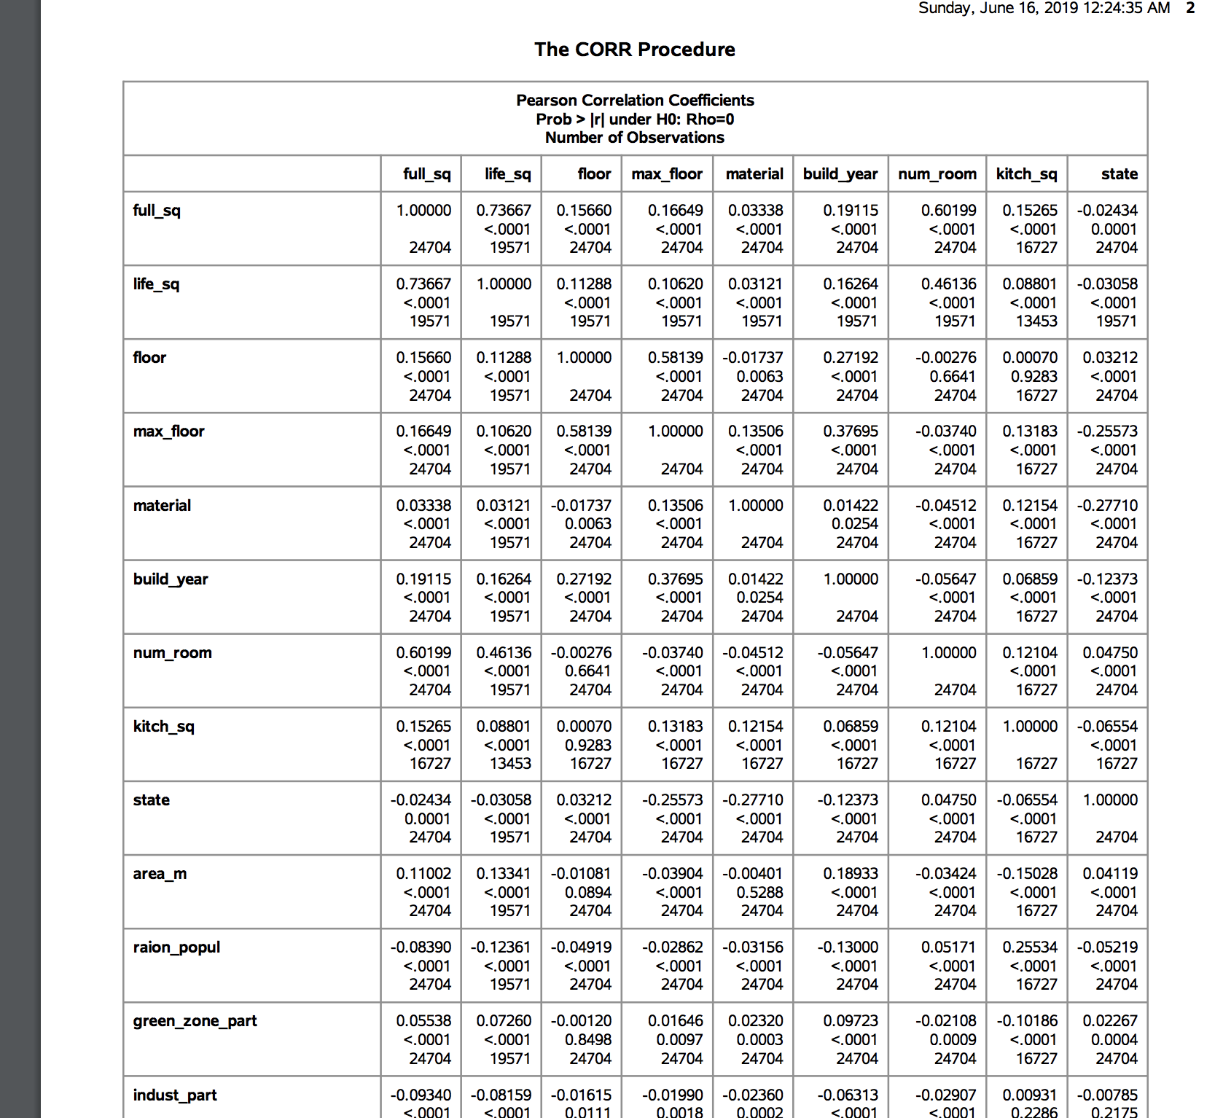

[Display: Multicollinearity Analysis]

* 1. Assumptions
     + Independence: For our analysis we assumed that the collected data are independently collected. There is no indication of data being dependent on other.
     + Normal Distribution: The response variable is assumed to be normally distributed across the measurements taken for independent variables.
     + Linearity: We checked area parameters and they seem to be linearly correlated to our dependent variable: price doc. For the variables we considered we didn’t find any variable that needed transformation.
     + As we can see in the diagram below, the price increases linearly as full_sq values increase. We can assume this data to be linearly related to Price doc and add this to the model without transformation

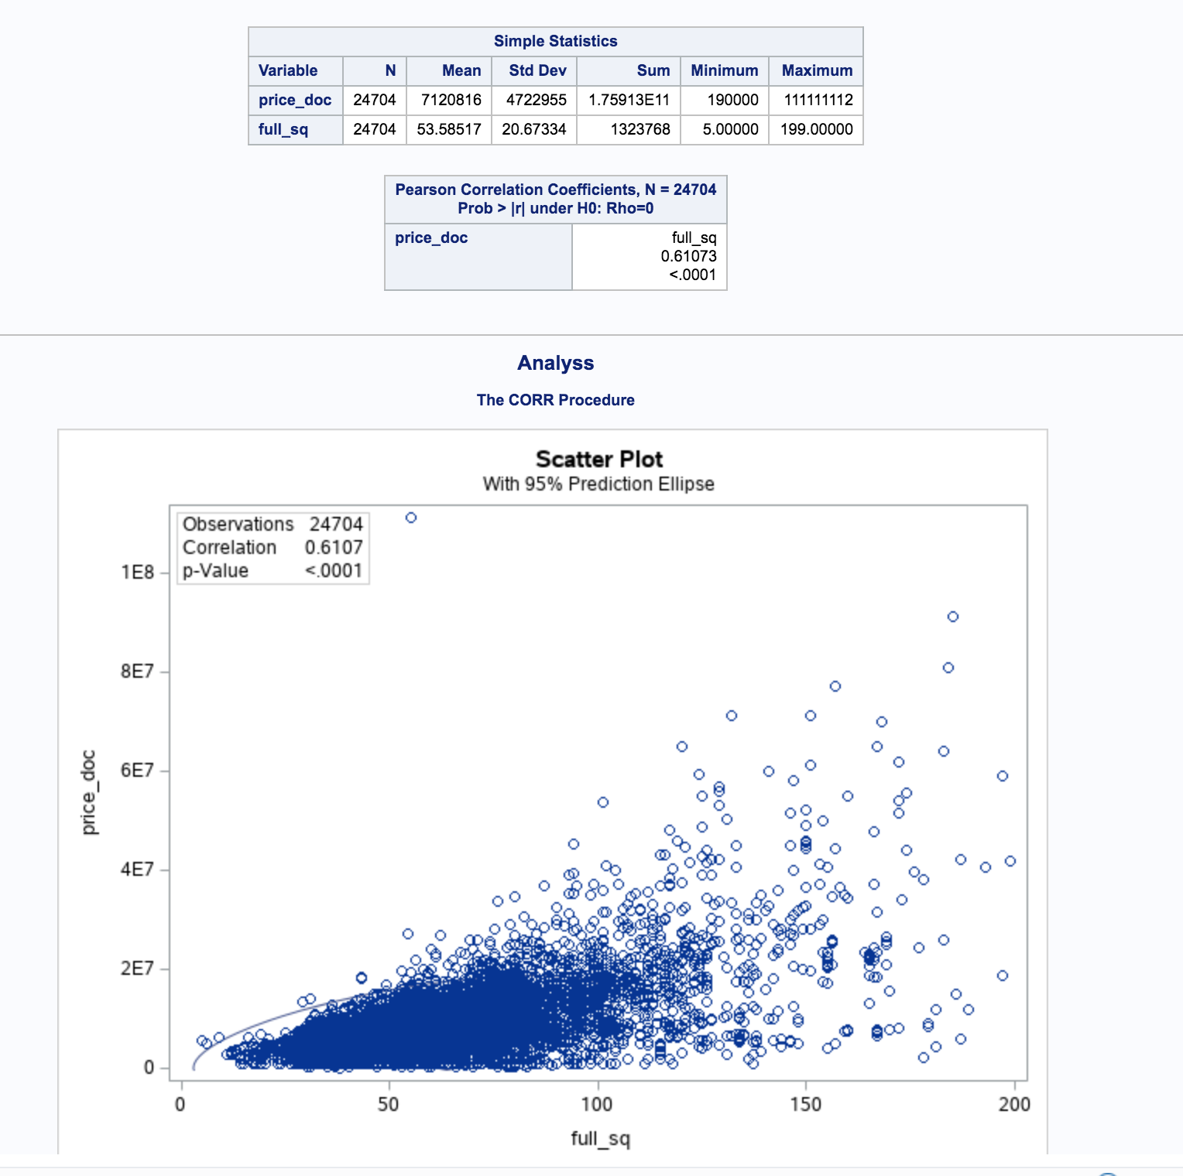

[Display: Scatter Plot for full_sq and price_doc]

* Variable Selection
  1. Based on the forward selection, backward selection, stepwise selection and Lasso, we choose 25 relevant variables with statistical significance
     + full_sq life_sq
     + floor
     + max_floor
     + material
     + build_year
     + num_room
     + kitch_sq
     + state
     + product_type
     + sub_area
     + area_m
     + raion_popul
     + green_zone_part
     + indust_part children_preschool preschool_quota
     + children_school school_quota
     + school_education_centers_raion
     + hospital_beds_raion healthcare_centers_raion
     + university_top_20_raion
     + sport_objects_raion additional_education_raion
     + culture_objects_top_25
     + culture_objects_top_25_raion
     + shopping_centers_raion office_raion
     + thermal_power_plant_raion incineration_raion
     + oil_chemistry_raion
     + radiation_raion railroad_terminal_raion big_market_raion
     + nuclear_reactor_raion
     + detention_facility_raion
* Model Selection
  1. After comparing the forward selection, backward selection, stepwise selection and Lasso techniques, we concluded that the backward selection is giving us the best result
  2. Adjusted R, AIC and AICC favored this method
  3. Summary Comparison

|  |  |  |  |  |
| --- | --- | --- | --- | --- |
|  | **Backward**  **Selection** | Stepwise  Selection | Forward  Selection | Lasso |
| Adjusted R-SQ | **0.67** | 0.61 | 0.61 | 0.48 |
| AIC | **235147** | 236113 | 236113 | 238259 |
| AICC | **235176** | 236115 | 236115 | 238259 |

* 1. Backward Selection Results

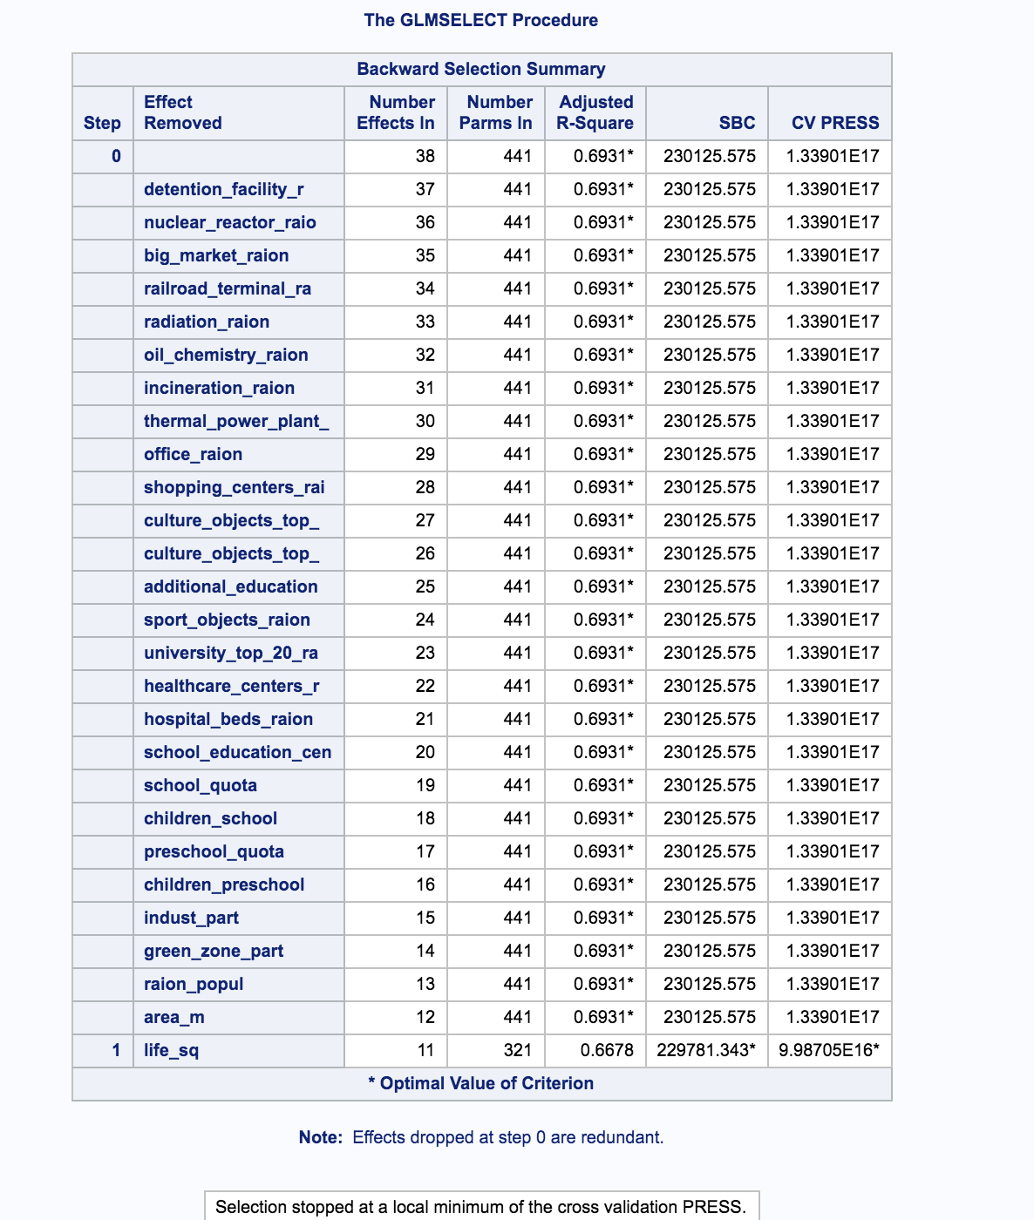

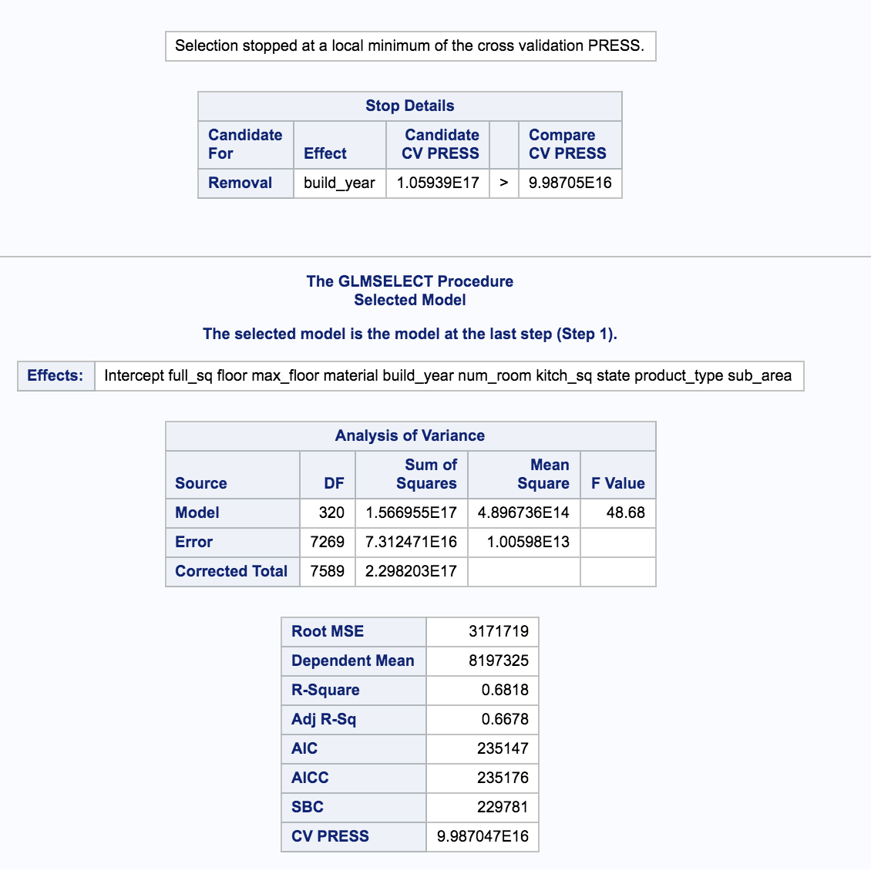

* 1. Stepwise Selection Results

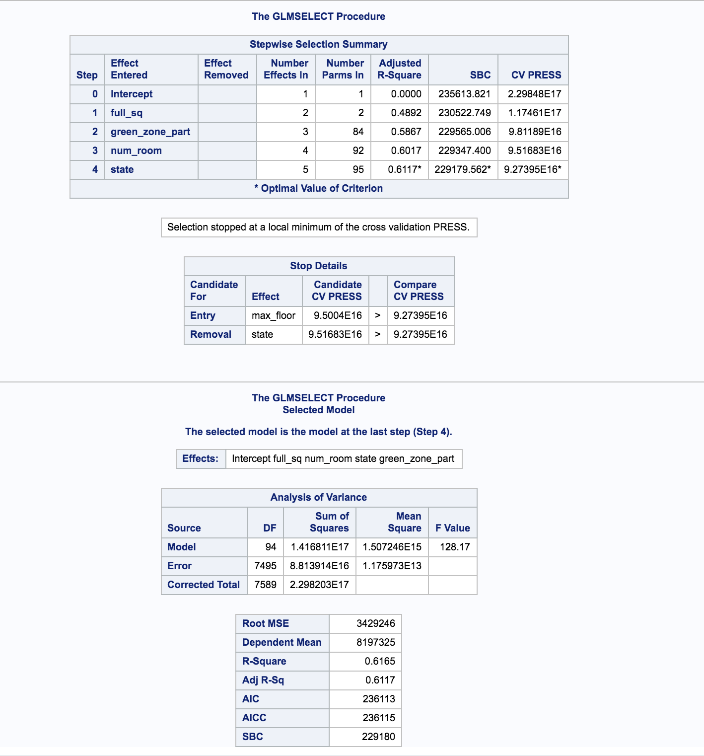

* 1. Forward Selection Results and Lasso Modeling Results

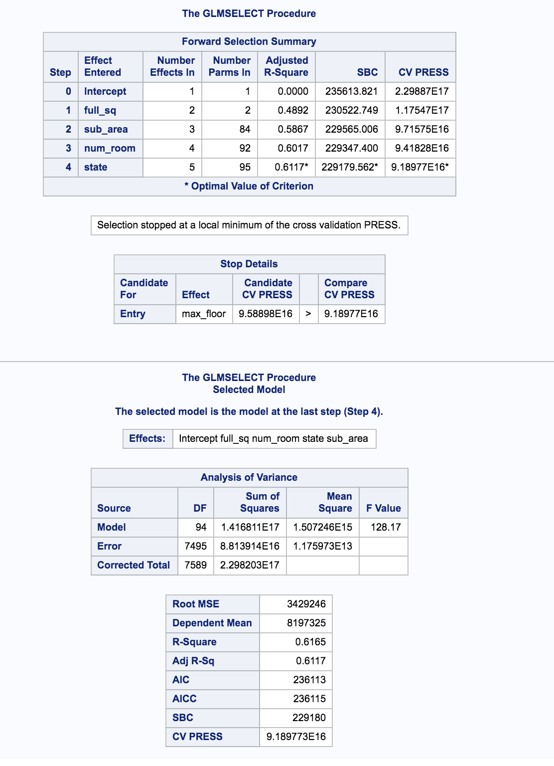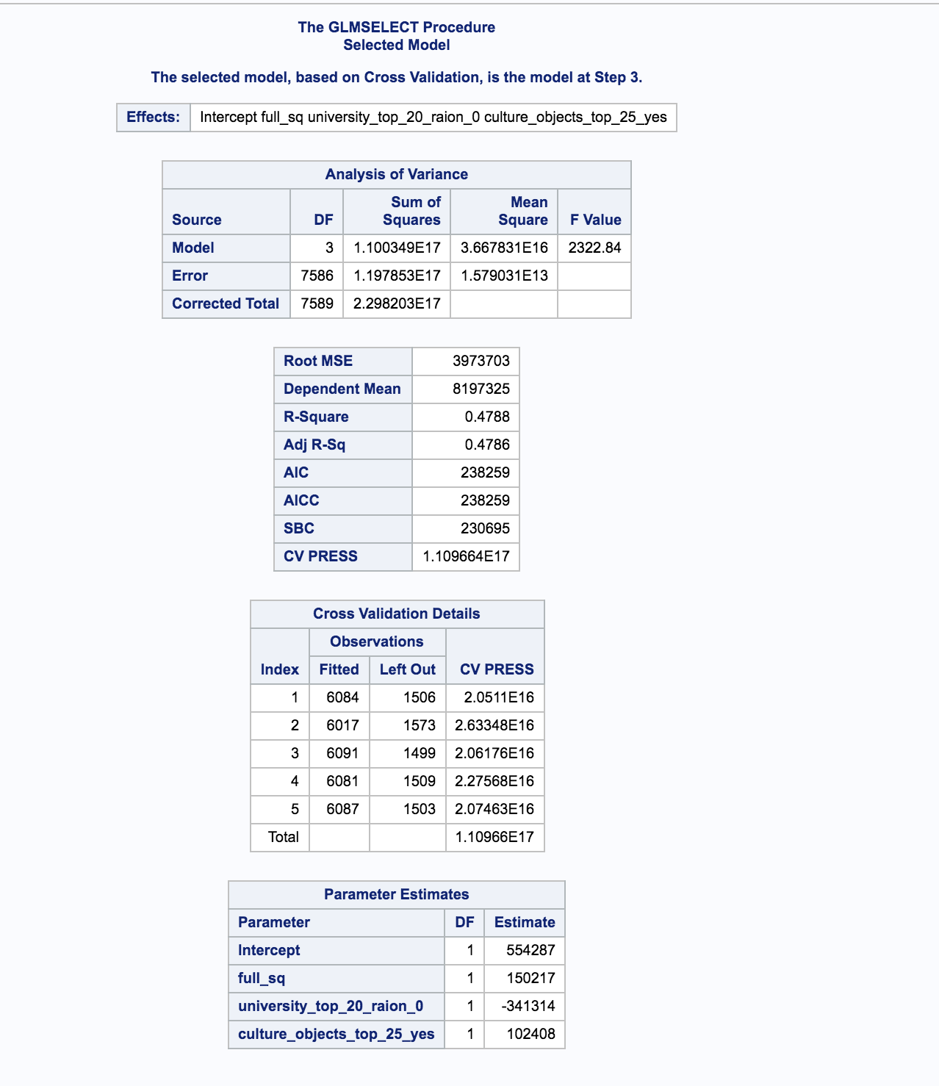

* Final Prediction
  1. We created different predictions based on selection models. Our final prediction is based on the backward selection model since that has the lowest Adjusted R squared Value
  2. But some of the predictions have missing values due to the limitation of the chosen model. So we have used some reasonable number to set values for these numbers such as averages

**GOAL2**

* Introduction

Sberbank, one of Russia’s largest bank, would like to predict average house prices based on historic trend. We used the time series analysis technic on aggregated monthly data to solve this problem

* Data Wrangling
  1. The timestamp if each house purchase record are written in the number of days since 12/30/1899. So we transform the data into the familiar YYYY-MM-DD format with R

|  |
| --- |
| # Select ID, timestamp and price, and transform to YYYY-MM-DD  goal2_data <- modelingData[c("id", "timestamp", "price_doc")]  goal2_data$timestamp <- as.Date(goal2_data$timestamp, origin = "1899-12-30") |

* 1. With Aggregate function in R, we could get the average monthly price. And we also define sequential month number to make the time series analysis easier

|  |
| --- |
| # Aggregate by month-year  goal2_agg <- aggregate(goal2_data, by=list(goal2_data$monthYear), FUN = mean)  goal2_agg <- goal2_agg[c("Group.1", "price_doc")]  names(goal2_agg) <- c("monthYear", "AvgPrice")  goal2_agg$monthNumber <- seq.int(nrow(goal2_agg)) |

* Plotting Time Series

The plotting and subsequent analysis is conducted with the SAS tool. We can see the overall trend of the mean price increase accompanied with oscillating ups and downs.

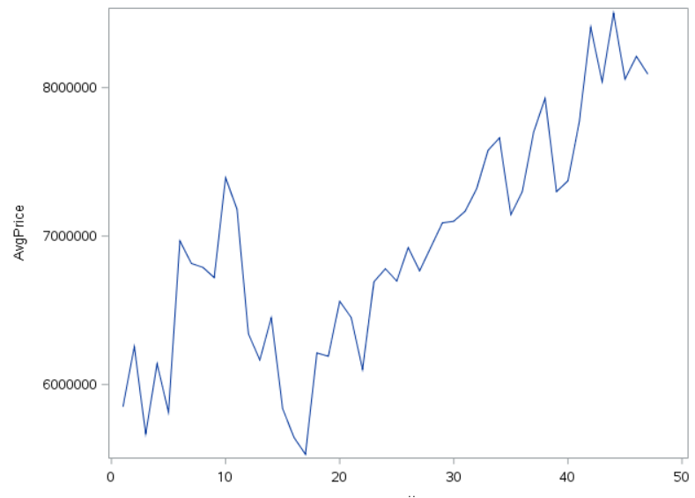

* Residual Series Modeling
  1. When fitting the data to OLS, we see the residuals are clustered along recent past. Positive residuals follow another positive residuals from previous observation, and so forth for negative residuals – hunch for autocorrelation
  2. The PACF result also suggest the autocorrelation. So we will Durbin-Watson statistics

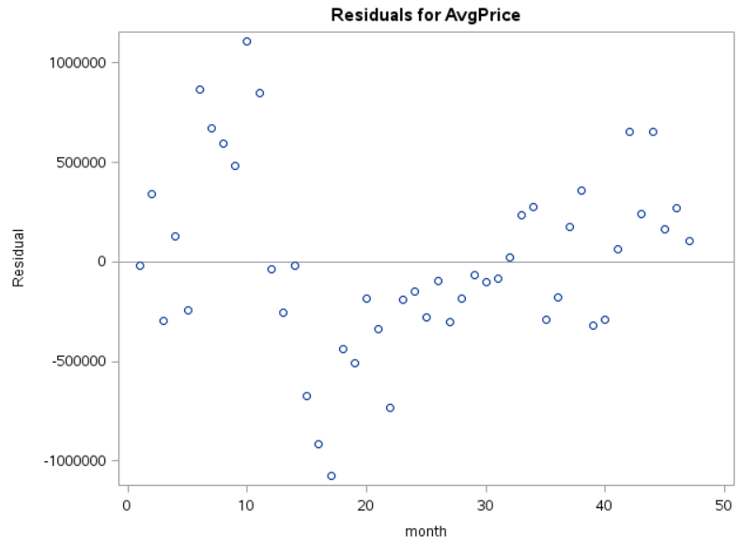 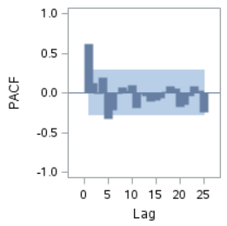

* 1. DW statistics value and Pr suggest there is a positive autocorrelation



* 1. Once corrected with AR(1), we see the residual autocorrelation is corrected based on DW value near to 2.0

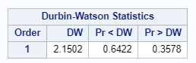 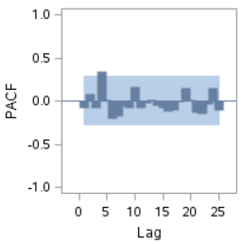

* 1. When comparing the AIC and SBC, we see corrected models are favored compared to the OLS. The figures are lower with Y-W estimates

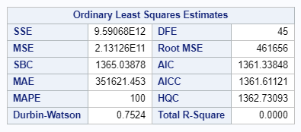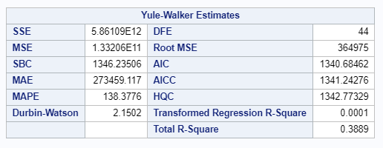

* Average House Price Prediction
  1. The monthly average price from July 2015 to June 2016 are predicted with the corrected estimates from SAS

|  |
| --- |
| PROC AUTOREG DATA=GOAL2_PRED ;  MODEL AVGPRICE = MONTH / NLAG = (1) DWPROB;  OUTPUT OUT = PREDS_PRICE P = PREDICTIONS LCL = LOWER UCL = UPPER PM = YTREND;  RUN; |

* 1. The SAS package help combine the trend estimate with the forecast residual analyzed in previous steps. The plot with 95% confidence interval, predictions and trend values are as following

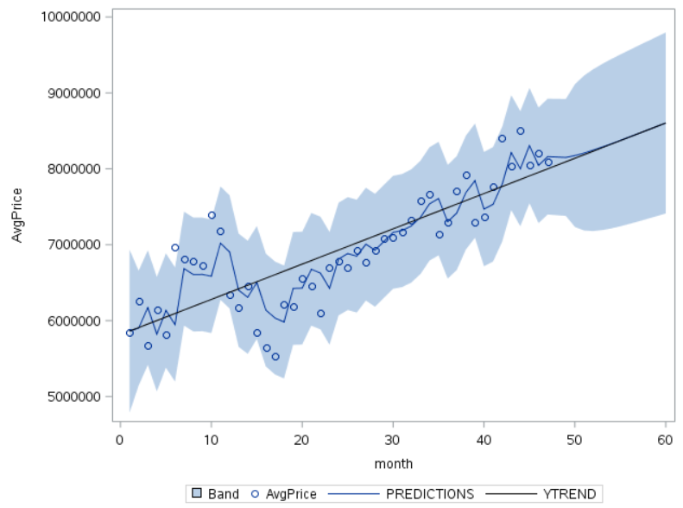

* 1. Predictions of the housing price with 95% confidence interval

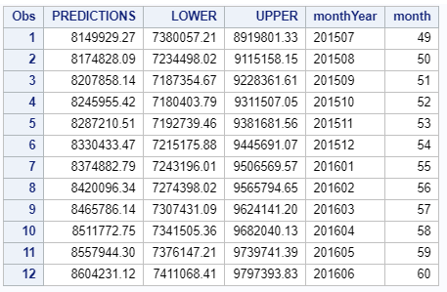

**Appendix 1: Data Dictionary**

**Major Variables**

|  |  |
| --- | --- |
| Variables | Description |
| price_doc | sale price (this is the target variable) |
| id | transaction id |
| timestamp | date of transaction |
| full_sq | total area in square meters, including loggias, balconies and other non-residential areas |
| life_sq | living area in square meters, excluding loggias, balconies and other non-residential areas |
| floor | for apartments, floor of the building |
| max_floor | number of floors in the building |
| material | wall material |
| build_year | year built |
| num_room | number of living rooms |
| kitch_sq | kitchen area |
| state | apartment condition |
| product_type | owner-occupier purchase or investment |
| sub_area | name of the district |

**Neighborhood Features**

|  |  |
| --- | --- |
| **Variables** | **Description** |
| area_m | Area, sq.m. |
| raion_popul | Number of municipality population. district |
| green_zone_part | Proportion of area of greenery in the total area |
| indust_part | Share of industrial zones in area of the total area |
| children_preschool | Number of pre-school age population |
| preschool_quota | Number of seats in pre-school organizations |
| preschool_education_centers_raion | Number of pre-school institutions |
| children_school | Population of school-age children |
| school_quota | Number of high school seats in area |
| school_education_centers_raion | Number of high school institutions |
| school_education_centers_top_20_raion | Number of high schools of the top 20 best schools in Moscow |
| hospital_beds_raion | Number of hospital beds for the district |
| healthcare_centers_raion | Number of healthcare centers in district |
| university_top_20_raion | Number of higher education institutions in the top ten ranking of the Federal rank |
| sport_objects_raion | Number of higher education institutions |
| additional_education_raion | Number of additional education organizations |
| culture_objects_top_25 | Presence of the key objects of cultural heritage (significant objects for the level of the RF constituent entities, city) |
| culture_objects_top_25_raion | Number of objects of cultural heritage |
| shopping_centers_raion | Number of malls and shopping centers in district |
| office_raion | Number of malls and shopping centers in district |
| thermal_power_plant_raion | Presence of thermal power station in district |
| incineration_raion | Presence of incinerators |
| oil_chemistry_raion | Presence of dirty industries |
| radiation_raion | Presence of radioactive waste disposal |
| railroad_terminal_raion | Presence of the railroad terminal in district |
| big_market_raion | Presence of large grocery / wholesale markets |
| nuclear_reactor_raion | Presence of existing nuclear reactors |
| detention_facility_raion | Presence of detention centers, prisons |
| full_all | Total number of population in the municipality |
| male_f | Male population |
| female_f | Female population |
| young_all | Population younger than working age |
| young_male | Male population younger than working age |
| young_female | Feale population younger than working age |
| work_all | Working-age population |
| work_male | Male working-age population |
| work_female | Female working-age population |
| ekder_all | Population older than working age |
| ekder_male | Male population older than working age |
| ekder_female | Female population older than working age |
| 0_6_all | Population aged 0-6 |
| 0_6_male | Male population aged 0-7 |
| 0_6_female | Female population aged 0-8 |
| 7_14_all | Population aged 7-14 |
| 7_14_male | Male population aged 7-14 |
| 7_14_female | Female population aged 7-14 |
| 0_17_all | Population aged 0-17 |
| 0_17_male | Male population aged 0-17 |
| 0_17_female | Female population aged 0-17 |
| 16_29_all | Population aged 16-19 |
| 16_29_male | Male population aged 16-19 |
| 16_29_female | Female population aged 16-19 |
| 0_13_all | Population aged 0-13 |
| 0_13_male | Male population aged 0-13 |
| 0_13_female | Female population aged 0-13 |
| raion_build_count_with_material_info | Number of building with material info in district |
| build_count_block | Share of block buildings |
| build_count_wood | Share of wood buildings |
| build_count_frame | Share of frame buildings |
| build_count_brick | Share of brick buildings |
| build_count_monolith | Share of monolith buildings |
| build_count_panel | Share of panel buildings |
| build_count_foam | Share of foam buildings |
| build_count_slag | Share of slag buildings |
| build_count_mix | Share of mixed buildings |
| raion_build_count_with_builddate_info | Number of building with build year info in district |
| build_count_before_1920 | Share of before_1920 buildings |
| build_count_1921-1945 | Share of 1921-1945 buildings |
| build_count_1946-1970 | Share of 1946-1970 buildings |
| build_count_1971-1995 | Share of 1971-1995 buildings |
| build_count_after_1995 | Share of after_1995 buildings |
| 7_14_male | Male population aged 7-14 |
| 7_14_female | Female population aged 7-14 |
| 0_17_all | Population aged 0-17 |
| 0_17_male | Male population aged 0-17 |
| 0_17_female | Female population aged 0-17 |
| 16_29_all | Population aged 16-19 |
| 16_29_male | Male population aged 16-19 |
| 16_29_female | Female population aged 16-19 |
| 0_13_all | Population aged 0-13 |
| 0_13_male | Male population aged 0-13 |
| 0_13_female | Female population aged 0-13 |
| metro_min_avto | Time to subway by car, min. |
| metro_km_avto | Distance to subway by car, km |
| metro_min_walk | Time to metro by foot |
| metro_km_walk | Distance to the metro, km |
| kindergarten_km | Distance to kindergarten |
| school_km | Distance to high school |
| park_km | Distance to park |
| green_zone_km | Distance to green zone |
| industrial_zone_km | Distance to industrial zone |
| water_treatment_km | Distance to water treatment |
| cemetery_km | Distance to the cemetery |
| incineration_km | Distance to the incineration |
| railroad_station_walk_km | Distance to the railroad station (walk) |
| railroad_station_walk_min | Time to the railroad station (walk) |
| ID_railroad_station_walk | Nearest railroad station id (walk) |
| railroad_station_avto_km | Distance to the railroad station (avto) |
| railroad_station_avto_min | Time to the railroad station (avto) |
| ID_railroad_station_avto | Nearest railroad station id (avto) |
| public_transport_station_km | Distance to the public transport station (walk) |
| public_transport_station_min_walk | Time to the public transport station (walk) |
| water_km | Distance to the water reservoir / river |
| water_1line | First line to the river (150 m) |
| mkad_km | Distance to MKAD (Moscow Circle Auto Road) |
| ttk_km | Distance to the TTC (Third Transport Ring) |
| sadovoe_km | Distance to the Garden Ring |
| bulvar_ring_km | The distance to the Boulevard Ring |
| kremlin_km | Distance to the city center (Kremlin) |
| big_road1_km | Distance to Nearest major road |
| ID_big_road1 | Nearest big road id |
| big_road1_1line | First line to the road (100 m for highways, 250 m to MKAD) |
| big_road2_km | The distance to next distant major road |
| ID_big_road2 | 2nd nearest big road id |
| railroad_km | Distance to the railway / Moscow Central Ring / open areas Underground |
| railroad_1line | First line to the railway (100 m) |
| zd_vokzaly_avto_km | Distance to train station |
| ID_railroad_terminal | Nearest railroad terminal id |
| bus_terminal_avto_km | Distance to bus terminal (avto) |
| ID_bus_terminal | Nearest bus terminal id |
| oil_chemistry_km | Distance to dirty industries |
| nuclear_reactor_km | Distance to nuclear reactor |
| radiation_km | Distance to burial of radioactive waste |
| power_transmission_line_km | Distance to power transmission line |
| thermal_power_plant_km | Distance to thermal power plant |
| ts_km | Distance to power station |
| big_market_km | Distance to grocery / wholesale markets |
| market_shop_km | Distance to markets and department stores |
| fitness_km | Distance to fitness |
| swim_pool_km | Distance to swimming pool |
| ice_rink_km | Distance to ice palace |
| stadium_km | Distance to stadium |
| basketball_km | Distance to the basketball courts |
| hospice_morgue_km | Distance to hospice/morgue |
| detention_facility_km | Distance to detention facility |
| public_healthcare_km | Distance to public healthcare |
| university_km | Distance to universities |
| workplaces_km | Distance to workplaces |
| shopping_centers_km | Distance to shopping centers |
| office_km | Distance to business centers/ offices |
| additional_education_km | Distance to additional education |
| preschool_km | Distance to preschool education organizations |
| big_church_km | Distance to large church |
| church_synagogue_km | Distance to Christian churches and Synagogues |
| mosque_km | Distance to mosques |
| theater_km | Distance to theater |
| museum_km | Distance to museums |
| exhibition_km | Distance to exhibition |
| catering_km | Distance to catering |
| ecology | Ecological zone where the house is located |
| green_part_500 | The share of green zones in 500 meters zone |
| prom_part_500 | The share of industrial zones in 500 meters zone |
| office_count_500 | The number of office space in 500 meters zone |
| office_sqm_500 | The square of office space in 500 meters zone |
| trc_count_500 | The number of shopping malls in 500 meters zone |
| trc_sqm_500 | The square of shopping malls in 500 meters zone |
| cafe_count_500 | The number of cafes or restaurants in 500 meters zone |
| cafe_sum_500_min_price_avg | Cafes and restaurant min average bill in 500 meters zone |
| cafe_sum_500_max_price_avg | Cafes and restaurant max average bill in 500 meters zone |
| cafe_avg_price_500 | Cafes and restaurant average bill in 500 meters zone |
| cafe_count_500_na_price | Cafes and restaurant bill N/A in 500 meters zone |
| cafe_count_500_price_500 | Cafes and restaurant bill, average under 500 in 500 meters zone |
| fcafe_count_500_price_1000 | Cafes and restaurant bill, average 500-1000 in 500 meters zone |
| cafe_count_500_price_1500 | Cafes and restaurant bill, average 1000-1500 in 500 meters zone |
| cafe_count_500_price_2500 | Cafes and restaurant bill, average 1500-2500 in 500 meters zone |
| cafe_count_500_price_4000 | Cafes and restaurant bill, average 2500-4000 in 500 meters zone |
| cafe_count_500_price_high | Cafes and restaurant bill, average over 4000 in 500 meters zone |
| big_church_count_500 | The number of big churches in 500 meters zone |
| church_count_500 | The number of churches in 500 meters zone |
| mosque_count_500 | The number of mosques in 500 meters zone |
| leisure_count_500 | The number of leisure facilities in 500 meters zone |
| sport_count_500 | The number of sport facilities in 500 meters zone |
| market_count_500 | The number of markets in 500 meters zone |
| green_part_1000 | The share of green zones in 1000 meters zone |
| prom_part_1000 | The share of industrial zones in 1000 meters zone |
| office_count_1000 | The number of office space in 1000 meters zone |
| office_sqm_1000 | The square of office space in 1000 meters zone |
| trc_count_1000 | The number of shopping malls in 1000 meters zone |
| trc_sqm_1000 | The square of shopping malls in 1000 meters zone |
| cafe_count_1000 | The number of cafes or restaurants in 1000 meters zone |
| cafe_sum_1000_min_price_avg | Cafes and restaurant min average bill in 1000 meters zone |
| cafe_sum_1000_max_price_avg | Cafes and restaurant max average bill in 1000 meters zone |
| cafe_avg_price_1000 | Cafes and restaurant average bill in 1000 meters zone |
| cafe_count_1000_na_price | Cafes and restaurant bill N/A in 1000 meters zone |
| cafe_count_1000_price_500 | Cafes and restaurant bill, average under 500 in 1000 meters zone |
| cafe_count_1000_price_1000 | Cafes and restaurant bill, average 500-1000 in 1000 meters zone |
| cafe_count_1000_price_1500 | Cafes and restaurant bill, average 1000-1500 in 1000 meters zone |
| cafe_count_1000_price_2500 | Cafes and restaurant bill, average 1500-2500 in 1000 meters zone |
| cafe_count_1000_price_4000 | Cafes and restaurant bill, average 2500-4000 in 1000 meters zone |
| cafe_count_1000_price_high | Cafes and restaurant bill, average over 4000 in 1000 meters zone |
| big_church_count_1000 | The number of big churches in 1000 meters zone |
| church_count_1000 | The number of churches in 1000 meters zone |
| mosque_count_1000 | The number of mosques in 1000 meters zone |
| leisure_count_1000 | The number of leisure facilities in 1000 meters zone |
| sport_count_1000 | The number of sport facilities in 1000 meters zone |
| market_count_1000 | The number of markets in 1000 meters zone |
| green_part_1500 | The share of green zones in 1500 meters zone |
| prom_part_1500 | The share of industrial zones in 1500 meters zone |
| office_count_1500 | The number of office space in 1500 meters zone |
| office_sqm_1500 | The square of office space in 1500 meters zone |
| trc_count_1500 | The number of shopping malls in 1500 meters zone |
| trc_sqm_1500 | The square of shopping malls in 1500 meters zone |
| cafe_count_1500 | The number of cafes or restaurants in 1500 meters zone |
| cafe_sum_1500_min_price_avg | Cafes and restaurant min average bill in 1500 meters zone |
| cafe_sum_1500_max_price_avg | Cafes and restaurant max average bill in 1500 meters zone |
| cafe_avg_price_1500 | Cafes and restaurant average bill in 1500 meters zone |
| cafe_count_1500_na_price | Cafes and restaurant bill N/A in 1500 meters zone |
| cafe_count_1500_price_500 | Cafes and restaurant bill, average under 500 in 1500 meters zone |
| cafe_count_1500_price_1000 | Cafes and restaurant bill, average 500-1000 in 1500 meters zone |
| cafe_count_1500_price_1500 | Cafes and restaurant bill, average 1000-1500 in 1500 meters zone |
| cafe_count_1500_price_2500 | Cafes and restaurant bill, average 1500-2500 in 1500 meters zone |
| cafe_count_1500_price_4000 | Cafes and restaurant bill, average 2500-4000 in 1500 meters zone |
| cafe_count_1500_price_high | Cafes and restaurant bill, average over 4000 in 1500 meters zone |
| big_church_count_1500 | The number of big churches in 1500 meters zone |
| church_count_1500 | The number of churches in 1500 meters zone |
| mosque_count_1500 | The number of mosques in 1500 meters zone |
| leisure_count_1500 | The number of leisure facilities in 1500 meters zone |
| sport_count_1500 | The number of sport facilities in 1500 meters zone |
| market_count_1500 | The number of markets in 1500 meters zone |
| green_part_2000 | The share of green zones in 2000 meters zone |
| prom_part_2000 | The share of industrial zones in 2000 meters zone |
| office_count_2000 | The number of office space in 2000 meters zone |
| office_sqm_2000 | The square of office space in 2000 meters zone |
| trc_count_2000 | The number of shopping malls in 2000 meters zone |
| trc_sqm_2000 | The square of shopping malls in 2000 meters zone |
| cafe_count_2000 | The number of cafes or restaurants in 1500 meters zone |
| cafe_sum_2000_min_price_avg | Cafes and restaurant min average bill in 2000 meters zone |
| cafe_sum_2000_max_price_avg | Cafes and restaurant max average bill in 2000 meters zone |
| cafe_avg_price_2000 | Cafes and restaurant average bill in 2000 meters zone |
| cafe_count_2000_na_price | Cafes and restaurant bill N/A in 2000 meters zone |
| cafe_count_2000_price_500 | Cafes and restaurant bill, average under 500 in 2000 meters zone |
| cafe_count_2000_price_1000 | Cafes and restaurant bill, average 500-1000 in 2000 meters zone |
| cafe_count_2000_price_1500 | Cafes and restaurant bill, average 1000-1500 in 2000 meters zone |
| cafe_count_2000_price_2500 | Cafes and restaurant bill, average 1500-2500 in 2000 meters zone |
| cafe_count_2000_price_4000 | Cafes and restaurant bill, average 2500-4000 in 2000 meters zone |
| cafe_count_2000_price_high | Cafes and restaurant bill, average over 4000 in 2000 meters zone |
| big_church_count_2000 | The number of big churches in 2000 meters zone |
| church_count_2000 | The number of churches in 2000 meters zone |
| mosque_count_2000 | The number of mosques in 2000 meters zone |
| leisure_count_2000 | The number of leisure facilities in 2000 meters zone |
| sport_count_2000 | The number of sport facilities in 2000 meters zone |
| market_count_2000 | The number of markets in 2000 meters zone |
| green_part_3000 | The share of green zones in 3000 meters zone |
| prom_part_3000 | The share of industrial zones in 3000 meters zone |
| office_count_3000 | The number of office space in 3000 meters zone |
| office_sqm_3000 | The square of office space in 3000 meters zone |
| trc_count_3000 | The number of shopping malls in 3000 meters zone |
| trc_sqm_3000 | The square of shopping malls in 3000 meters zone |
| cafe_count_3000 | The number of cafes or restaurants in 1500 meters zone |
| cafe_sum_3000_min_price_avg | Cafes and restaurant min average bill in 3000 meters zone |
| cafe_sum_3000_max_price_avg | Cafes and restaurant max average bill in 3000 meters zone |
| cafe_avg_price_3000 | Cafes and restaurant average bill in 3000 meters zone |
| cafe_count_3000_na_price | Cafes and restaurant bill N/A in 3000 meters zone |
| cafe_count_3000_price_500 | Cafes and restaurant bill, average under 500 in 3000 meters zone |
| cafe_count_3000_price_1000 | Cafes and restaurant bill, average 500-1000 in 3000 meters zone |
| cafe_count_3000_price_1500 | Cafes and restaurant bill, average 1000-1500 in 3000 meters zone |
| cafe_count_3000_price_2500 | Cafes and restaurant bill, average 1500-2500 in 3000 meters zone |
| cafe_count_3000_price_4000 | Cafes and restaurant bill, average 2500-4000 in 3000 meters zone |
| cafe_count_3000_price_high | Cafes and restaurant bill, average over 4000 in 3000 meters zone |
| big_church_count_3000 | The number of big churches in 3000 meters zone |
| church_count_3000 | The number of churches in 3000 meters zone |
| mosque_count_3000 | The number of mosques in 3000 meters zone |
| leisure_count_3000 | The number of leisure facilities in 3000 meters zone |
| sport_count_3000 | The number of sport facilities in 3000 meters zone |
| market_count_3000 | The number of markets in 3000 meters zone |
| green_part_5000 | The share of green zones in 5000 meters zone |
| prom_part_5000 | The share of industrial zones in 5000 meters zone |
| office_count_5000 | The number of office space in 5000 meters zone |
| office_sqm_5000 | The square of office space in 5000 meters zone |
| trc_count_5000 | The number of shopping malls in 5000 meters zone |
| trc_sqm_5000 | The square of shopping malls in 5000 meters zone |
| cafe_count_5000 | The number of cafes or restaurants in 1500 meters zone |
| cafe_sum_5000_min_price_avg | Cafes and restaurant min average bill in 5000 meters zone |
| cafe_sum_5000_max_price_avg | Cafes and restaurant max average bill in 5000 meters zone |
| cafe_avg_price_5000 | Cafes and restaurant average bill in 5000 meters zone |
| cafe_count_5000_na_price | Cafes and restaurant bill N/A in 5000 meters zone |
| cafe_count_5000_price_500 | Cafes and restaurant bill, average under 500 in 5000 meters zone |
| cafe_count_5000_price_1000 | Cafes and restaurant bill, average 500-1000 in 5000 meters zone |
| cafe_count_5000_price_1500 | Cafes and restaurant bill, average 1000-1500 in 5000 meters zone |
| cafe_count_5000_price_2500 | Cafes and restaurant bill, average 1500-2500 in 5000 meters zone |
| cafe_count_5000_price_4000 | Cafes and restaurant bill, average 2500-4000 in 5000 meters zone |
| cafe_count_5000_price_high | Cafes and restaurant bill, average over 4000 in 5000 meters zone |
| big_church_count_5000 | The number of big churches in 5000 meters zone |
| church_count_5000 | The number of churches in 5000 meters zone |
| mosque_count_5000 | The number of mosques in 5000 meters zone |
| leisure_count_5000 | The number of leisure facilities in 5000 meters zone |
| sport_count_5000 | The number of sport facilities in 5000 meters zone |
| market_count_5000 | The number of markets in 5000 meters zone |

**Data Wrangling Detail**

|  |  |  |  |
| --- | --- | --- | --- |
| Category | Original  Value | Transformed Value | Method / Explanation |
| timestamp | Integer | Date | Dates are the common way of presenting time values |
| full_sq | NA | 54.3 | Used means of the category for values greater than or equal to 2 |
| full_sq | 0 | 54.3 | Used means of the category for values greater than or equal to 2 |
| full_sq | 1 | 54.3 | Used means of the category for values greater than or equal to 2 |
| life_sq | NA | 34.6 | Used means of the category for values greater than or equal to 2 |
| life_sq | 0 | 34.6 | Used means of the category for values greater than or equal to 2 |
| life_sq | 1 | 34.6 | Used means of the category for values greater than or equal to 2 |
| floor | NA | 8 | Used means of the category |
| floor | 0 | 1 | All structures must have at least one floor. |
| max_floor | NA | Set to “floor” category value | Maximum floor value is unknowable.  Set to most reliable data about the number of floors for the structure. |
| max_floor | 0 | Set to “floor” category value | Maximum floor value is unknowable.  Set to most reliable data about the number of floors for the structure. |
| material | NA | 1 | Most common material type |
| build_year | 4965 | 1965 | Appears to be a typo |
| build_year | 1691 | 1991 | Appears to be a typo |
| build_year | 20052009 | 2007 | Original value appears to be a range of 2005-2009.  Used the means of the range. |
| build_year | 71 | 1971 | Appears to be missing the 1900 in front of the year |
| build_year | NA | 1985 | Used means of the category for values greater than 215. |
| build_year | 0 | 1985 | Used means of the category for values greater than 215. |
| build_year | 1 | 1985 | Used means of the category for values greater than 215. |
| build_year | 3 | 1985 | Used means of the category for values greater than 215. |
| build_year | 20 | 1985 | Used means of the category for values greater than 215. |
| build_year | 215 | 1985 | Used means of the category for values greater than 215. |
| num_rooms | NA | 2 | Used means of the category for values greater than 2. |
| num_rooms | 0 | 1 | Unable to have a zero rooms |
| kitchen_sq | NA | 6.0 | Used means of the category |
| kitchen_sq | 1974 | 1 | The value was the same as the “build_year” category |
| kitchen_sq | 2013 | 1 | The value was the same as the “build_year” category |
| kitchen_sq | 2014 | 1 | The value was the same as the “build_year” category |
| kitchen_sq | 620 | 1 | The value was larger than the entire structure. |
| kitchen_sq | 1970 | 1 | The value was larger than the entire structure. |
| state | NA | 2 | Used the means of the category. |
| state | 33 | 3 | Appears to be a typo |
| preschool_quota | NA | 3273.8 | Used the means of the category. |
| school_quota | NA | 1194.8 | Used the means of the category. |
| raion_build_count_with_material_info | NA | 328.2 | Used the means of the category. |
| build_cont_wood | NA | 50.2 | Used the means of the category. |
| build_count_frame | NA | 40.3 | Used the means of the category. |
| build_count_brick | NA | 108.1 | Used the means of the category. |
| build_count_  monolith | NA | 12.0 | Used the means of the category. |
| build_count_panel | NA | 107.5 | Used the means of the category. |
| build_count_foam | NA | 0.2 | Used the means of the category. |
| build_count_slag | NA | 4.5 | Used the means of the category. |
| build_count_mix | NA | 0.6 | Used the means of the category. |
| raion_build_count_with_builddate_info | NA | 327.9 | Used the means of the category. |
| build_count_before_1920 | NA | 18.8 | Used the means of the category. |
| build_count_1921-  1945 | NA | 26.6 | Used the means of the category. |
| build_count_1946-  1970 | NA | 141.0 | Used the means of the category. |
| build_count_1971-  1995 | NA | 80.4 | Used the means of the category. |
| build_count_after_  1995 | NA | 61.1 | Used the means of the category. |
| metro_min_walk | NA | 42.8 | Used the means of the category. |
| metro_km_walk | NA | 5.5 | Used the means of the category. |
| railroad_station_  walk_km | NA | 4.4 | Used the means of the category. |
| railroad_station_  walk_min | NA | 52.7 | Used the means of the category. |
| ID_railroad_station_walk | NA | 38.9 | Used the means of the category. |
| cafe_sum_500_min_price_avg | NA | 740.3 | Used the means of the category. |
| cafe_sum_500_max_price_avg | NA | 1245.6 | Used the means of the category. |
| cafe_avg_price_500 | NA | 993.0 | Used the means of the category. |
| cafe_sum_1000_  min_price_avg | NA | 710.1 | Used the means of the category. |
| cafe_sum_1000_  max_price_avg | NA | 1205.4 | Used the means of the category. |
| cafe_avg_price_  1000 | NA | 957.7 | Used the means of the category. |
| cafe_sum_1500_  min_price_avg | NA | 713.2 | Used the means of the category. |
| cafe_sum_1500_  max_price_avg | NA | 1204.7 | Used the means of the category. |
| cafe_avg_price_  1500 | NA | 958.9 | Used the means of the category. |
| cafe_sum_2000_  min_price_avg | NA | 719.8 | Used the means of the category. |
| cafe_sum_2000_  max_price_avg | NA | 1210.8 | Used the means of the category. |
| cafe_avg_price_  2000 | NA | 965.3 | Used the means of the category. |
| cafe_sum_3000_  min_price_avg | NA | 765.7 | Used the means of the category. |
| cafe_sum_3000_  max_price_avg | NA | 1283.1 | Used the means of the category. |
| cafe_avg_price_  3000 | NA | 1024.4 | Used the means of the category. |
| prom_part_5000 | NA | 10.3 | Used the means of the category. |
| cafe_sum_5000_  min_price_avg | NA | 765.5 | Used the means of the category. |
| cafe_sum_5000_  max_price_avg | NA | 1278.9 | Used the means of the category. |
| cafe_avg_price_  5000 | NA | 1022.2 | Used the means of the category. |

**Appendix 2: Code**

1. Goal 1- Data importing with SAS

/* MODELING DATA */

%web_drop_table(WORK.MODELING);

FILENAME REFFILE '/folders/myfolders/DataFiles/modelingData_Adj_06-13.csv';

PROC IMPORT DATAFILE=REFFILE

DBMS=CSV

OUT= WORK.MODELING;

GETNAMES=YES;

guessingrows=12200;

RUN;

PROC CONTENTS DATA=WORK.MODELING; RUN;

%web_open_table(WORK.MODELING);

/* PROJECTION DATA */

%web_drop_table(WORK.PROJECTION);

FILENAME REFFILE '/folders/myfolders/DataFiles/projectionData_Adj_06-13.csv';

PROC IMPORT DATAFILE=REFFILE

DBMS=CSV

OUT= WORK.PROJECTION;

GETNAMES=YES;

guessingrows= max;

RUN;

PROC CONTENTS DATA=WORK.PROJECTION; RUN;

%web_open_table(WORK.PROJECTION);

1. Goal 1 – SAS code for data wrangling

/* MODELING DATA CLEANING */

data WORK.CLEAN_MODELING ;

set WORK.MODELING;

region=compress(sub_area,"'");

if full_sq = 5326 then delete;

if full_sq >200 then delete;

if full_sq <2 then full_sq = 54.3;

if missing(full_sq) then full_sq = 54.3;

if life_sq = 7478 then delete;

/* if full_sq >200 then delete; */

if full_sq <2 then full_sq = 34.6;

if missing(full_sq) then full_sq = 34.6;

if floor = 77 then delete;

if floor = 0 then floor =1;

if missing(floor) then floor = 8;

if max_floor = 0 then max_floor=floor;

if max_floor > 98 then delete;

if missing(max_floor) then max_floor=floor;

if missing(material) then material = 1;

if build_year = 4965 then build_year = 1965;

if build_year = 1691 then build_year = 1991;

if build_year = 20052009 then build_year = 2007;

if build_year = 71 then build_year = 1971;

if build_year < 220 then delete;

if missing(build_year) then build_year = 1985;

if num_rooms = 0 then num_rooms = 1;

if missing(num_rooms) then num_rooms = 2;

if kitch_sq = 1974 then kitch_sq = 1;

if kitch_sq = 2013 then kitch_sq = 1;

if kitch_sq = 2014 then kitch_sq = 1;

if kitch_sq > 500 then delete;

if missing(kitch_sq) then kitch_sq = 6;

if state = 33 then state = 3;

if missing(state) then state = 2;

if missing(preschool_quota) then preschool_quota = 3273.8;

if missing(school_quota) then school_quota = 1194.8;

if missing(raion_build_count_with_material_) then raion_build_count_with_material_ = 328.2;

if missing(build_cont_wood) then build_cont_wood = 50.2;

if missing(build_count_frame) then build_count_frame = 40.3;

if missing(build_count_brick) then build_count_brick = 108.1;

if missing(build_count_monolith) then build_count_monolith = 12.0;

if missing(build_count_panel) then build_count_panel = 107.5;

if missing(build_count_foam) then build_count_foam = 0.2;

if missing(build_count_slag) then build_count_slag = 4.5;

if missing(build_count_mix) then build_count_mix = 0.6;

if missing(raion_build_count_with_builddate) then raion_build_count_with_builddate = 327.9;

if missing(build_count_before_1920) then build_count_before_1920 = 18.8;

if missing(build_count_1921_1945) then build_count_1921_1945 = 26.6;

if missing(build_count_1946_1970) then build_count_1946_1970 = 141.0;

if missing(build_count_1971_1995) then build_count_1971_1995 = 80.4;

if missing(build_count_after_1995) then build_count_after_1995 = 61.1;

if missing(metro_min_walk) then metro_min_walk = 42.8;

if missing(metro_km_walk) then metro_km_walk = 5.5;

if missing(railroad_station_walk_km) then railroad_station_walk_km = 4.4;

if missing(railroad_station_walk_min) then railroad_station_walk_min = 52.7;

if missing(ID_railroad_station_walk) then ID_railroad_station_walk = 38.9;

if missing(cafe_sum_500_min_price_avg) then cafe_sum_500_min_price_avg = 740.3;

if missing(cafe_sum_500_max_price_avg) then cafe_sum_500_max_price_avg = 1245.6;

if missing(cafe_avg_price_500) then cafe_avg_price_500 = 993.0;

if missing(cafe_sum_1000_min_price_avg) then cafe_sum_1000_min_price_avg = 710.1;

if missing(cafe_sum_1000_max_price_avg) then cafe_sum_1000_max_price_avg = 1205.4;

if missing(cafe_avg_price_1000) then cafe_avg_price_1000 = 957.7;

if missing(cafe_sum_1500_min_price_avg) then cafe_sum_1500_min_price_avg = 713.2;

if missing(cafe_sum_1500_max_price_avg) then cafe_sum_1500_max_price_avg = 1204.7;

if missing(cafe_avg_price_1500) then cafe_avg_price_1500 = 958.9;

if missing(cafe_sum_2000_min_price_avg) then cafe_sum_2000_min_price_avg = 719.8;

if missing(cafe_sum_2000_max_price_avg) then cafe_sum_2000_max_price_avg = 1210.8;

if missing(cafe_avg_price_2000) then cafe_avg_price_2000 = 965.3;

if missing(cafe_sum_3000_min_price_avg) then cafe_sum_3000_min_price_avg = 765.7;

if missing(cafe_sum_3000_max_price_avg) then cafe_sum_3000_max_price_avg = 1283.1;

if missing(cafe_avg_price_3000) then cafe_avg_price_3000 = 1024.4;

if missing(prom_part_5000) then prom_part_5000 = 10.3;

if missing(cafe_sum_5000_min_price_avg) then cafe_sum_5000_min_price_avg = 765.5;

if missing(cafe_sum_5000_max_price_avg) then cafe_sum_5000_max_price_avg = 1278.9;

if missing(cafe_avg_price_5000) then cafe_avg_price_5000 = 1022.2;

idd = input(VAR1, 8.);

run;

/* proc print data=WORK.CLEAN_MODELING (obs=10); run; */

/* PROJECTION DATA CLEANING */

data WORK.CLEAN_PROJECTION ;

set WORK.PROJECTION;

region=compress(sub_area,"'");

if full_sq = 5326 then delete;

if full_sq >200 then delete;

if full_sq <2 then full_sq = 54.3;

if missing(full_sq) then full_sq = 54.3;

if life_sq = 7478 then delete;

/* if full_sq >200 then delete; */

if full_sq <2 then full_sq = 34.6;

if missing(full_sq) then full_sq = 34.6;

if floor = 77 then delete;

if floor = 0 then floor =1;

if missing(floor) then floor = 8;

if max_floor = 0 then max_floor =floor;

if max_floor > 98 then delete;

if missing(max_floor) then max_floor=floor;

if missing(material) then material = 1;

if build_year = 4965 then build_year = 1965;

if build_year = 1691 then build_year = 1991;

if build_year = 20052009 then build_year = 2007;

if build_year = 71 then build_year = 1971;

if build_year < 220 then delete;

if missing(build_year) then build_year = 1985;

if num_rooms = 0 then num_rooms = 1;

if missing(num_rooms) then num_rooms = 2;

if kitch_sq = 1974 then kitch_sq = 1;

if kitch_sq = 2013 then kitch_sq = 1;

if kitch_sq = 2014 then kitch_sq = 1;

if kitch_sq > 500 then delete;

if missing(kitch_sq) then kitch_sq = 6;

if state = 33 then state = 3;

if missing(state) then state = 2;

if missing(preschool_quota) then preschool_quota = 3273.8;

if missing(school_quota) then school_quota = 1194.8;

if missing(raion_build_count_with_material_) then raion_build_count_with_material_ = 328.2;

if missing(build_cont_wood) then build_cont_wood = 50.2;

if missing(build_count_frame) then build_count_frame = 40.3;

if missing(build_count_brick) then build_count_brick = 108.1;

if missing(build_count_monolith) then build_count_monolith = 12.0;

if missing(build_count_panel) then build_count_panel = 107.5;

if missing(build_count_foam) then build_count_foam = 0.2;

if missing(build_count_slag) then build_count_slag = 4.5;

if missing(build_count_mix) then build_count_mix = 0.6;

if missing(raion_build_count_with_builddate) then raion_build_count_with_builddate = 327.9;

if missing(build_count_before_1920) then build_count_before_1920 = 18.8;

if missing(build_count_1921_1945) then build_count_1921_1945 = 26.6;

if missing(build_count_1946_1970) then build_count_1946_1970 = 141.0;

if missing(build_count_1971_1995) then build_count_1971_1995 = 80.4;

if missing(build_count_after_1995) then build_count_after_1995 = 61.1;

if missing(metro_min_walk) then metro_min_walk = 42.8;

if missing(metro_km_walk) then metro_km_walk = 5.5;

if missing(railroad_station_walk_km) then railroad_station_walk_km = 4.4;

if missing(railroad_station_walk_min) then railroad_station_walk_min = 52.7;

if missing(ID_railroad_station_walk) then ID_railroad_station_walk = 38.9;

if missing(cafe_sum_500_min_price_avg) then cafe_sum_500_min_price_avg = 740.3;

if missing(cafe_sum_500_max_price_avg) then cafe_sum_500_max_price_avg = 1245.6;

if missing(cafe_avg_price_500) then cafe_avg_price_500 = 993.0;

if missing(cafe_sum_1000_min_price_avg) then cafe_sum_1000_min_price_avg = 710.1;

if missing(cafe_sum_1000_max_price_avg) then cafe_sum_1000_max_price_avg = 1205.4;

if missing(cafe_avg_price_1000) then cafe_avg_price_1000 = 957.7;

if missing(cafe_sum_1500_min_price_avg) then cafe_sum_1500_min_price_avg = 713.2;

if missing(cafe_sum_1500_max_price_avg) then cafe_sum_1500_max_price_avg = 1204.7;

if missing(cafe_avg_price_1500) then cafe_avg_price_1500 = 958.9;

if missing(cafe_sum_2000_min_price_avg) then cafe_sum_2000_min_price_avg = 719.8;

if missing(cafe_sum_2000_max_price_avg) then cafe_sum_2000_max_price_avg = 1210.8;

if missing(cafe_avg_price_2000) then cafe_avg_price_2000 = 965.3;

if missing(cafe_sum_3000_min_price_avg) then cafe_sum_3000_min_price_avg = 765.7;

if missing(cafe_sum_3000_max_price_avg) then cafe_sum_3000_max_price_avg = 1283.1;

if missing(cafe_avg_price_3000) then cafe_avg_price_3000 = 1024.4;

if missing(prom_part_5000) then prom_part_5000 = 10.3;

if missing(cafe_sum_5000_min_price_avg) then cafe_sum_5000_min_price_avg = 765.5;

if missing(cafe_sum_5000_max_price_avg) then cafe_sum_5000_max_price_avg = 1278.9;

if missing(cafe_avg_price_5000) then cafe_avg_price_5000 = 1022.2;

log_full_sq= log(full_sq);

idd= idd+28000;

run;

1. Goal 1 – SAS code to check assumptions

**proc** **corr** data=housing.clean_modeling rank PEARSON

plots (maxpoints = **40000**)= scatter(alpha=**.05** );

var full_sq life_sq floor max_floor material;

with price_doc ;

title Analyss ;

**run**;

**proc** **corr** data=housing.clean_modeling rank PEARSON

plots (maxpoints = **40000**)= all;

var full_sq;

with price_doc ;

title Analyss ;

**run**;

**proc** **corr** data= housing.clean_modeling rank PEARSON

plots (maxpoints = **40000**)= scatter(alpha=**.05** );

var build_year num_room

kitch_sq state area_m ;

with price_doc ;

title Analyss ;

**run**;

**proc** **corr** data=work.refined_data rank PEARSON

plots (maxpoints = **40000**)= scatter(alpha=**.05** );

var raion_popul green_zone_part

indust_part children_preschool preschool_quota

children_school

;

with price_doc ;

title Analyss ;

**run**;

**proc** **corr** data=work.refined_data rank PEARSON

plots (maxpoints = **40000**)= scatter(alpha=**.05** );

var children_school school_quota school_education_centers_raion

hospital_beds_raion healthcare_centers_raion

1. Goal 1 – SAS code to check multicollinearity

**proc** **corr** data= housing.clean_modeling;

var full_sq life_sq floor max_floor material build_year num_room

kitch_sq state area_m raion_popul green_zone_part

indust_part children_preschool preschool_quota

children_school school_quota school_education_centers_raion

hospital_beds_raion healthcare_centers_raion university_top_20_raion

sport_objects_raion additional_education_raion

culture_objects_top_25_raion shopping_centers_raion ;

**run**;

**proc** **glm** data=housing.clean_modeling;

class preschool_quota children_school school_quota;

model price_doc = full_sq raion_popul life_sq preschool_quota children_school school_quota;

**run**;

1. Goal 1 – SAS code for model comparison

/* Backward selection. */

**proc** **glmselect** data=housing.merged_data;

class life_sq floor max_floor material build_year num_room

kitch_sq state product_type sub_area area_m raion_popul green_zone_part

indust_part children_preschool preschool_quota

children_school school_quota school_education_centers_raion

hospital_beds_raion healthcare_centers_raion university_top_20_raion

sport_objects_raion additional_education_raion culture_objects_top_25

culture_objects_top_25_raion shopping_centers_raion office_raion

thermal_power_plant_raion incineration_raion oil_chemistry_raion

radiation_raion railroad_terminal_raion big_market_raion nuclear_reactor_raion

detention_facility_raion;

model price_doc = full_sq life_sq floor max_floor material build_year num_room

kitch_sq state product_type sub_area area_m raion_popul green_zone_part

indust_part children_preschool preschool_quota

children_school school_quota school_education_centers_raion

hospital_beds_raion healthcare_centers_raion university_top_20_raion

sport_objects_raion additional_education_raion culture_objects_top_25

culture_objects_top_25_raion shopping_centers_raion office_raion

thermal_power_plant_raion incineration_raion oil_chemistry_raion

radiation_raion railroad_terminal_raion big_market_raion nuclear_reactor_raion

detention_facility_raion

/ selection=Backward(stop=CV) cvmethod=random(**5**) stats=adjrsq;

output out = results p = predict ;

**run**;

**data** result_backward_selection ;

set results;

price_doc = predict;

if missing(predict) then price_doc = **140000**;

keep id price_doc;

where idd > **28000**;

**proc** **export** data=result_backward_selection dbms=csv

outfile="/folders/myfolders/stats2_hw/term_proj1/output/result_backward_selection.csv"

replace;

**run**;

**proc** **print** data = result_Backward_selection;

**run**;

/* Stepwise. */

**proc** **glmselect** data=housing.merged_data;

class life_sq floor max_floor material build_year num_room

kitch_sq state product_type sub_area area_m raion_popul green_zone_part

indust_part children_preschool preschool_quota

children_school school_quota school_education_centers_raion

hospital_beds_raion healthcare_centers_raion university_top_20_raion

sport_objects_raion additional_education_raion culture_objects_top_25

culture_objects_top_25_raion shopping_centers_raion office_raion

thermal_power_plant_raion incineration_raion oil_chemistry_raion

radiation_raion railroad_terminal_raion big_market_raion nuclear_reactor_raion

detention_facility_raion;

model price_doc = full_sq life_sq floor max_floor material build_year num_room

kitch_sq state product_type sub_area area_m raion_popul green_zone_part

indust_part children_preschool preschool_quota

children_school school_quota school_education_centers_raion

hospital_beds_raion healthcare_centers_raion university_top_20_raion

sport_objects_raion additional_education_raion culture_objects_top_25

culture_objects_top_25_raion shopping_centers_raion office_raion

thermal_power_plant_raion incineration_raion oil_chemistry_raion

radiation_raion railroad_terminal_raion big_market_raion nuclear_reactor_raion

detention_facility_raion

/ selection=Stepwise(stop=CV) cvmethod=random(**5**) stats=adjrsq;

output out = results p = predict ;

**run**;

/* LASSO */

proc glmselect data= WORK.MERGED_DATA;

class full_sq life_sq floor max_floor material build_year num_room

kitch_sq state product_type sub_area area_m raion_popul green_zone_part

indust_part children_preschool preschool_quota

children_school school_quota school_education_centers_raion

hospital_beds_raion healthcare_centers_raion university_top_20_raion

sport_objects_raion additional_education_raion culture_objects_top_25

culture_objects_top_25_raion shopping_centers_raion office_raion

thermal_power_plant_raion incineration_raion oil_chemistry_raion

radiation_raion railroad_terminal_raion big_market_raion nuclear_reactor_raion

detention_facility_raion;

model price_doc = full_sq -- detention_facility_raion

/ selection=LASSO(choose=CV stop=CV) CVdetails;

output out = results p = predict ;

run;

data result_LASSO_selection ;

set results;

price_doc = predict;

if missing(predict) then price_doc = 140000;

keep id price_doc;

where idd > 28000;

proc print data = result_LASSO_selection; run;

1. Goal 2 – R code for data wrangling

# Project 01, Goal 02 - Pankaj, Karl, Shawn

# ---------------------------------------------------------

# MSDS 6372 - Project#1 - Goal 2

#

# Part A - Data Wrangling for Time Series Analysis

# Pankaj Kumar, Shawn Jung, Karl Jurek

# ---------------------------------------------------------

# reading the original modeling data

modelingData <- read.csv("C:/Users/shawn/OneDrive/SMU/Applied Stat/Project01/modelingData.csv")

# Select ID, timestamp and price, and transform to YYYY-MM-DD

goal2_data <- modelingData[c("id", "timestamp", "price_doc")]

goal2_data$timestamp <- as.Date(goal2_data$timestamp, origin = "1899-12-30")

# Parsing day, month, year and month-year as separate columns

goal2_data$day <- format.Date(goal2_data$timestamp, "%d")

goal2_data$month <- format.Date(goal2_data$timestamp, "%m")

goal2_data$year <- format.Date(goal2_data$timestamp, "%Y")

goal2_data$monthYear <- paste(goal2_data$year, goal2_data$month, sep="")

# Aggregate by month-year

goal2_agg <- aggregate(goal2_data, by=list(goal2_data$monthYear), FUN = mean)

goal2_agg <- goal2_agg[c("Group.1", "price_doc")]

names(goal2_agg) <- c("monthYear", "AvgPrice")

goal2_agg$monthNumber <- seq.int(nrow(goal2_agg))

# write to CSV to load from SAS

write.csv(goal2_agg, file="goal2data.csv")

1. Goal 2 – SAS code for Time Series Analysis

/* ---------------------------------------------------------

* MSDS 6372 - Project#1 - Goal 2

* Part B - Time Seriese Analysis of Average House Price

* Pankaj Kumar, Shawn Jung, Karl Jurek

* --------------------------------------------------------- */

/* set data file location as a separate path */

FILENAME REFILL '/home/shawnj0/sasuser.v94/AppliedStat/goal2data.csv';

/* load the wrangled data as GOAL2 */

PROC IMPORT DATAFILE=REFILL

DBMS=CSV

OUT= GOAL2;

GETNAMES=YES;

RUN;

/* inspect if the data is ok */

PROC CONTENTS DATA=GOAL2; RUN;

PROC PRINT DATA=GOAL2;RUN;

/* visually inspect the data */

PROC SGPLOT DATA=GOAL2;

SERIESE X = MONTH Y= AVGPRICE;

RUN;

/* Fit a simple lineare regression */

PROC GLM DATA=GOAL2 PLOT=ALL ;

MODEL AVGPRICE = MONTH /SOLUTION;

RUN;

/* obtain residuals and plot them */

PROC REG DATA=GOAL2;

MODEL AVGPRICE = MONTH / R ;

OUTPUT OUT=GOAL2RESID R=RESID ;

RUN;

PROC SGPLOT DATA=GOAL2RESID;

SERIESE X = MONTH Y= RESID;

RUN;

/* Check autocorrelation on residuals */

PROC AUTOREG DATA=GOAL2RESID; /* without any lag */

MODEL RESID = MONTH / DWPROB;

RUN;

PROC AUTOREG DATA=GOAL2RESID; /* try lag 1 */

MODEL RESID = MONTH / NLAG = (1) DWPROB;

RUN;

/* Prediction of residuals - prepare data */

DATA FORPRED;

INPUT monthYear $ month @@ ; cards;

201507 49

201508 50

201509 51

201510 52

201511 53

201512 54

201601 55

201602 56

201603 57

201604 58

201605 59

201606 60

;

RUN;

DATA GOAL2_PRED; /*combine two sets */

SET GOAL2 FORPRED;

RUN;

/* running prediction */

PROC AUTOREG DATA=GOAL2_PRED ;

MODEL AVGPRICE = MONTH / NLAG = (1) DWPROB;

OUTPUT OUT = PREDS_PRICE P = PREDICTIONS LCL = LOWER UCL = UPPER PM = YTREND;

RUN;

PROC SGPLOT DATA = PREDS_PRICE;

BAND X = MONTH UPPER = UPPER LOWER = LOWER;

SCATTER X = MONTH Y = AVGPRICE;

SERIES X = MONTH Y = PREDICTIONS;

SERIES X = MONTH Y = YTREND / LINEATTRS= (COLOR=BLACK);

RUN;

PROC PRINT DATA=PREDS_PRICE;RUN;

/* forecating July 2015 to June 2016 */

DATA FORCASTED_PRICE;

SET PREDS_PRICE;

KEEP MONTH MONTHYEAR PREDICTIONS LOWER UPPER;

WHERE MONTH > 47;

;

PROC PRINT DATA=FORCASTED_PRICE;RUN;